Lab 07:
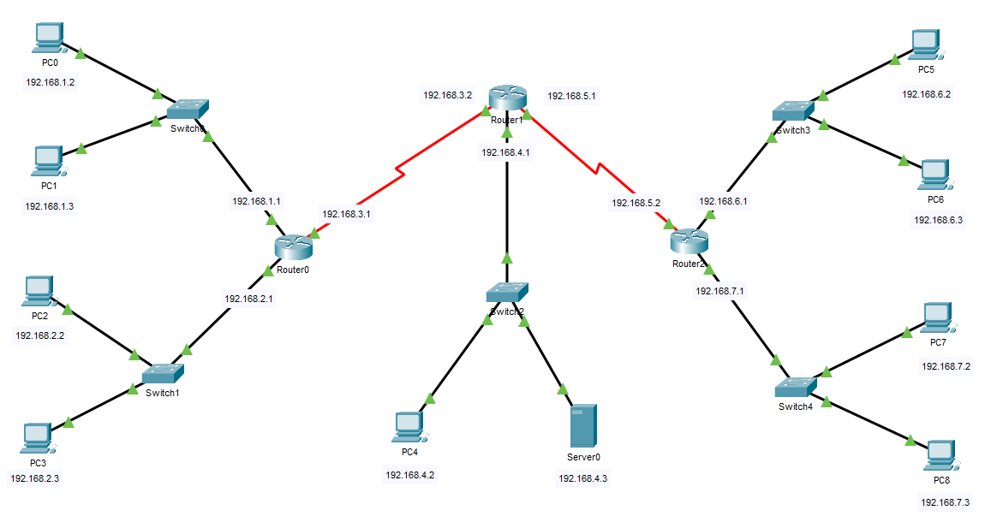

Question1: Implement the given topology in cisco packet tracers and configure HTTP, HTTPS, FTP, and SMTP/POP3 services on a given server and then perform the following tasks then show their simulations.
- Block all the traffic from PC 0 to every end device.
- Block ping request from PC2 to all other PCs where as other PCs can ping PC2.
- Block all http requests from PC5 to server.
- Block all FTP request from PC7 to FTP server.
- Block SMTP requests from all the devices that are connected to switch3.
- Block POP3 requests from all the devices that are connected to switch4.
- Block all ping request to PC4.
- Note down the ACLs that are applied and list down their rules.
- Differentiate between Standard and Extended ACLs.
- Explain why does the order of rules matter in ACL.

